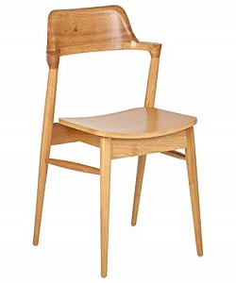

Rosewood chair

$8.85

Availability: In stock

Description

This Mid-Century Modern Chair will bring a smart style twist to your dining space. A curved back adds comfort. Its versatile, compact size can also work as extra seating in your living space or as a desk chair.